Name: Class:

Task 1
1. Look at the storage devices in the table below. For each one, tick whether it is magnetic, optical or solid state.
Storage device | Magnetic | Optical | Solid state
Hard disk drive
Blu-ray
CD ROM
USB flash drive
DVD RAM
SSD hard drive
SD card
Floppy disk drive
Backup tape drive
2. There are three different methods that are used to store data.
Name the three different methods.
Method 1:

Method 2:

Method 3:

Task 2
Magnetic hard disks use a solid disk to store data.
(a) Complete the table below to explain the different parts of a magnetic hard disk.
Hard disk part | Explanation
Drive head
Actuator
Drive spindle
Platter
Track
Sector
(b) Describe the process involved in reading data from a hard disk.

Task 3
Music used to be commonly sorted on vinyl records before CDs. Both are still in use today.
Research both vinyl records and CDs. Make notes of the similarities and differences between the two in the table below. The first similarity between the two has been given as an example.
 | Vinyl records | CDs
Similarities | - Makes use of a 12” disk. | - Makes use of a 12 cm disk.
Differences

Task 4
The following shows a diagram of one memory cell inside a flash memory unit.
(a) Label the diagram to show:
- The isolation layers
- The floating gate
- The control gate
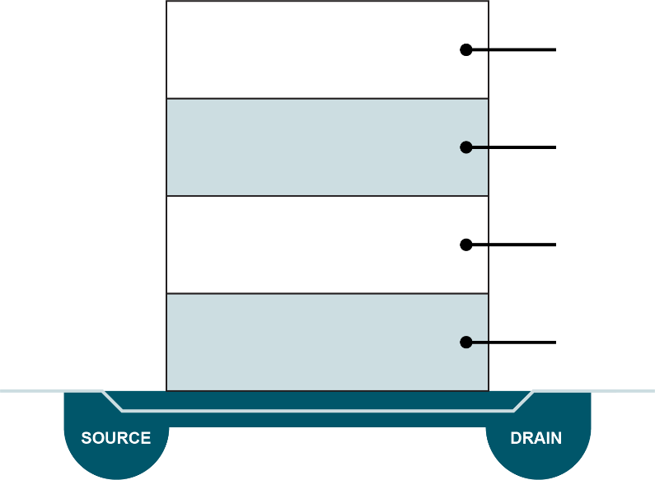
(b) How is it possible for such a flash memory unit to store data?

